Analysis and Operations on a Real-Time Signal – Seismogram

1. Introduction
A seismogram is a record produced by a seismograph that measures and records the motion of the ground during an earthquake. The signal provides crucial information about the earthquake’s intensity, duration, and energy. In this experiment, we analyze a real-time seismogram of a major earthquake in Japan (the 2011 Tohoku earthquake that occurred on March 11, 2011). The signal is studied using various operations in the time and frequency domains, such as time delay, time reversal, time scaling, energy and power calculation, and Fourier transform to obtain the magnitude and phase spectrum.

2. Objective
- To analyze a real-time seismogram signal of the 2011 Japan earthquake.
- To perform basic signal operations: Time delay, Time reversal, Time scaling.
- To compute the energy and power of the signal.
- To perform Fourier Transform and study the magnitude and phase spectrum.
- To understand how these operations are useful in real-life applications such as earthquake monitoring and signal interpretation.

3. Methodology
1. Input Signal: The real-time seismogram data of the Japan earthquake was originally obtained as a screenshot from the IRIS (Incorporated Research Institutions for Seismology) website. The image was then processed using WebPlotDigitizer to convert it into a digital form (time vs amplitude data), which was imported into MATLAB as a CSV file.
2. Operations Performed:
- Time Delay: The signal was delayed by 5 seconds to observe how timing affects signal synchronization.
- Time Reversal: The time axis was inverted to observe the signal in reverse order, useful for system testing.
- Time Scaling: The signal was scaled by 0.5 (expanded), showing slower signal variation in time.
- Energy and Power: Calculated using the trapezoidal numerical integration method.
- Fourier Transform: Applied to analyze the signal in the frequency domain and obtain its magnitude and phase spectra.
3. Software Used: MATLAB (R2025a).
4. Dataset: Seismogram of Japan Earthquake (March 11, 2011) extracted from IRIS and digitized using WebPlotDigitizer.

clc
clear
close all;

%Load recorded readings' CSV file
data = readmatrix("C:\Users\Admin\Downloads\Default Dataset (3).csv");

% Separate columns (time and amplitude)
t = data(:,1); % Time values
x = data(:,2); % Amplitude values

% Plot seismogram
figure;
plot(t, x, 'y');
xlabel('Time (s)');
ylabel('Amplitude');
title('Japan''s Seismogram');
grid on;
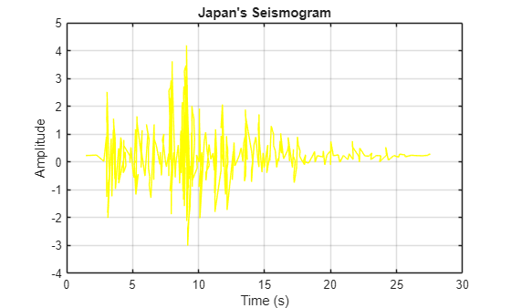
% Time delay
plot(t+5, x, 'r', 'LineWidth', 1.2);
axis([0 30 -4 5])
hold on;
xlabel('Time (s)');
ylabel('Amplitude');
title('Seismogram Time Shifted by 5s');
grid on;
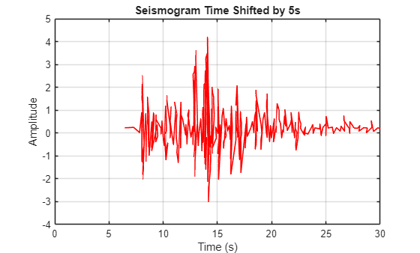

% time scaling expansion
a=0.5
a = 0.5000
plot(t/a, x, 'r', 'LineWidth', 1.2);
axis([-1 60 -4 5])
hold on;
xlabel('Time (s)');
ylabel('Amplitude');
title(' Expanded Seismogram');
grid on;
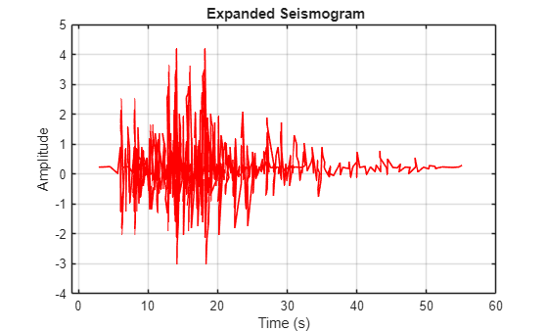
% time reversal
plot(-t, x, 'r', 'LineWidth', 1.2);
axis([-35 0 -4 5])
hold on;
xlabel('Time (s)');
ylabel('Amplitude');
title('Reversed Seismogram');
grid on;
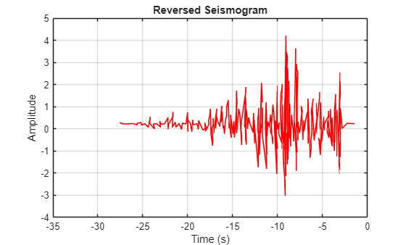
clc; clear; close all;
data = readmatrix("C:\Users\Admin\Downloads\Default Dataset (3).csv");

t = data(:,1); % Time values
x = data(:,2); % Amplitude values
figure;
plot(t, x, 'y');
xlabel('Time (s)');
ylabel('Amplitude');
title('Japan''s Seismogram');
grid on;

% Energy & Power of signal
T=0.2
T = 0.2000
E = trapz(t, abs(x).^2);
disp(['Energy of this signal is ', num2str(E), ' J'])
Energy of this signal is 12.1553 J
plot(t,x)
xlabel('Time (s)');
ylabel('Amplitude');
title('Energy of Seismogram');
grid on;
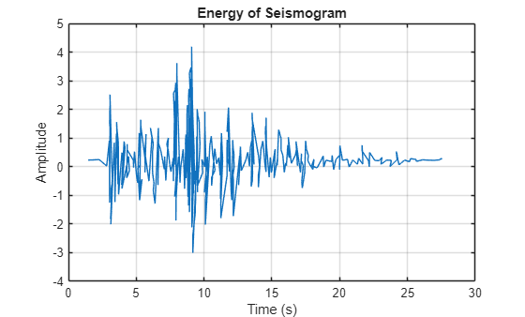
P=(1/T)*E;
disp(['Power of this signal is ', num2str(P), ' W'])
Power of this signal is 60.7765 W
% Import and Plot Seismogram
clc; clear; close all;

% Load your CSV file
data = readmatrix("C:\Users\Admin\Downloads\Default Dataset (3).csv");

% Separate columns (time and amplitude)
t = data(:,1); % Time values
x = data(:,2); % Amplitude values
figure;
plot(t, x, 'y');
xlabel('Time (s)');
ylabel('Amplitude');
title('Japan''s Seismogram');
grid on;
subplot(3,1,1)
plot(t, x)
xlabel("Time")
ylabel("Amplitude")
title("Signal in Time Domain")
grid on

w = -20:0.001:50;
l = length(w);
x2 = zeros(1, l);

for i = 1:l
x1 = x .* exp((-1i) * w(i) * t);
x2(i) = trapz(t, x1);
end

subplot(3,1,2)
plot(w, abs(x2),'g')
xlabel("Frequency")
ylabel("Magnitude")
title("Magnitude Spectrum")
grid on;

x3 = angle(x2);
subplot(3,1,3)
plot(w, x3,'r')
xlabel("Frequency")
ylabel("Phase")
title("Phase Spectrum")
grid on;
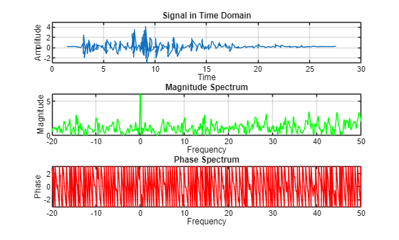

5. Results and Discussion

A. Time Domain Analysis
1. Time Delay (5 seconds): The signal was shifted by +5 seconds.
Practical Use: Helps synchronize seismogram data from multiple sensors placed at different locations to identify the epicenter and propagation time.
2. Time Reversal: The signal was flipped along the time axis.
Practical Use: Useful for system analysis and for designing matched filters to detect similar earthquake patterns.
3. Time Scaling (0.5): The signal was stretched by a factor of 0.5 (expanded in time).
Practical Use: Time-scaling models how signals change when recorded at different speeds or sampling rates, or to analyze lower-frequency seismic waves.

B. Energy and Power Analysis
From the MATLAB calculations:
Energy (E): 12.1553 J
Power (P): 60.7765 W
Interpretation: The signal’s energy indicates the total strength of the earthquake vibrations recorded. The power gives the rate at which the energy is transmitted — helping seismologists compare the intensity of different events.

C. Fourier Transform
The Fourier Transform decomposed the signal into its frequency components.
Plots of:
- Magnitude Spectrum: Shows dominant frequency bands of the earthquake vibrations.
- Phase Spectrum: Represents the phase shift of each frequency component.
Practical Use:
- Helps identify the predominant vibration frequencies of the ground.
- Aids in designing structures (e.g., buildings, bridges) that can withstand the specific frequency ranges of seismic waves.

6. References
1] https://geoserver.iris.edu/events#zoom=0&lat=67.27204&lon=-25.83984&layers=FFFFFFFFFFFFFFFFBFFFFFTFFF

7. Conclusion
In this experiment, a real-time seismogram of the 2011 Japan earthquake was analyzed using various signal operations. Time delay, reversal, and scaling provided insights into signal manipulation techniques relevant to synchronization, pattern recognition, and system response analysis. The computed energy and power quantified the earthquake’s intensity. The Fourier Transform revealed frequency characteristics essential for understanding ground motion behavior.
Overall, the experiment demonstrates how signals and systems concepts are directly applicable to real-world seismic data analysis, aiding in earthquake monitoring, disaster preparedness, and civil engineering design.

